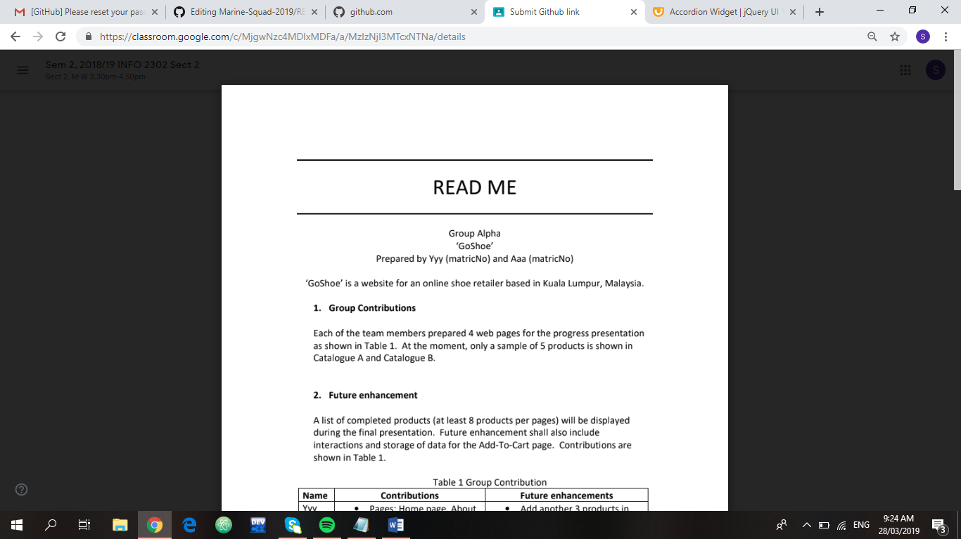

**Group Name: Marine Squad**

**Project Name : ‘Save our Marine Life’**

Prepared by Shazrina (1624336), Aisyah (1620632),

Syazaa (1711566), Zannat (1632738), Nadia (1714160)

‘Save our Marine Life’ is a website to encourage people to care about

ocean life more and also contributing their part towards the ecosystem as a citizen of the earth.

**1.** **Group Contributions**

**2.** **Future Enhancements**

|  |  |  |
| --- | --- | --- |
| **NAME** | **CONTRIBUTIONS** | **ENHANCEMENTS** |
| Shazrina | The Team, About Marine Life, and Documentaries. | * More organized styling. * Used HTML, CSS, and Javascript. * Used iframe. * Edit codes which are not working. * Incorporate slideshow. |
| Nur Aisyah | News, Statistic, and Merchandise. | * More organized styling. * Edit more on CSS and Javascript to make the web more interesting. * Used jQuery to enhance features |
| Syazaa | Leader, in charge of the Homepage, and compile everything to ensure the synchronization. | * Improvise homepage * Enhance UI for all pages * Enhance styling design * Compile all the codes |
| Zannat | Introduction, Mission, Vision, and Collaboration | * Added styling * Used HTML,CSS,Javascript * edited codes * Edited pictures |
| Nadia |  |  |

**3.** **Use of third-party resources**

|  |  |  |
| --- | --- | --- |
| **Web elements** | **Team members** | **Modifications** |
| * Fonts were taken from <https://fonts.googleapis.com> * Styling based on [www.w3schools.com](http://www.w3schools.com) * Iframe elements. * Organisational chart coding from <https://codepen.io/danyadsmith/pen/yNpqav> | Shazrina | - Used Satisfy and Alegreya Sans fonts.   * Video slideshow and videos are from youtube. * Organisational chart with each team members picture. * Used javascript for slideshow option. * Edited Nahreen’s and Nadia’s part. |
| * News: source taken from <https://www.independent.co.uk/topic/marine-life> and <https://www.nationalgeographic.com.au/> * Statistics: source taken from [http://www.unesco.org](http://www.unesco.org/) ,and used jQuery plugin * Merchandise: image from Google * Styling based on [www.w3schools.com](http://www.w3schools.com) <https://codepen.io/>, and [www.youtube.com](http://www.youtube.com). | Aisyah | * Used image slider and java to display news update. * Used jQuery plugin to make statistic more visualize. * Used javascript for the calculation part. * Most of the editing refers to in-class learning (image slider, hyperlink, division, calculation) |
| * Social Media such as Facebook and Google Account, to be linked under the registration of our webpage membership. * Icons were taken from <https://fontawesome.com/> | Syazaa | * Social media link redirect to the user’s respective account * The icon is used to navigate the user for subscriptions. |
|  | Zannat |  |
|  | Nadia |  |